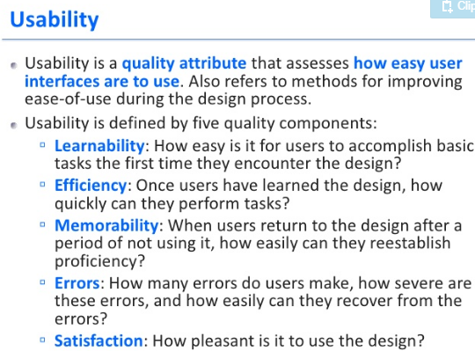

**Testing checklist includes:**  
**1)**Functionality Testing  
**2)** Usability testing  
**3)**Interface testing  
**4)** Compatibility testing  
**5)** Performance testing  
**6)**Security testing  
<http://www.softwaretestinghelp.com/usability-testing-guide/>

### Usability test

A usability test makes sure that the interface of a solution is built in a way that fits the user’s expectations with respect to meeting requirements (effectiveness) easily (efficiently) in a simplistic satisfying manner.

### Why is usability testing performed?

Web and mobile applications rule the business world in recent times. These apps being efficient, effective, easy, simple, appealing, engaging etc. is very critical for them to be embraced by the customers. Usability testing is all about determining if a site is what the user would want to use and come back to or not.

**Who performs usability testing?**

It can be done as an internal process, when the designers, developers and anyone else can sit down and analyze their system and get the results. Based on these results, the design and/or code can be modified to be in accordance with the changes they all agree on.

A more advanced approach is to hire real time users and give them particular tasks. A facilitator/s can devise these tasks and get the results from the users.

**The users can then provide information, on whether:**

1. the task was successful or not
2. the task could be performed easily
3. Was the experience interesting, engaging or annoying – their feeling towards the software

**Step #1) Identifying the users to perform the usability test** – it helps to choose the set of users that is close to how the real time users are going to be. Care has to be taken not to pick experts or complete newbies. The experts are going to simply run through the entire process and the novices need lots of background training to even get started- neither situation is optimum.

**Step #2)** **Designing the tasks that the users are going to perform on the application** –A list of situations that the users are going to use the application for are to be made prior to starting the test. This can include something like: ‘Search for an X-box and buy it” or ‘submit a customer care question” etc. on an eCommerce site. The tasks should closely represent the real transactions the users would use the site for.

**Step #3) Facilitating the testing**– The usability team will have the users perform the tasks on the site and are going to gather information regarding the test progress and results. It really makes a huge difference when the design team participates while the users are working on the application. It gives them a better picture about how the app was used and where it did not deliver what the user wanted etc, firsthand.

**Step #4)** **Analyze results** – At the end of the test, we might end up with the time it took to perform tasks, whether the task was successful or not etc, so basically raw data. The results have to be presented to all the stakeholders and analyzed for identification of potential problem areas.

The end results or outcome of a usability testing is not defects. It is simple information on how the user felt, what they liked, what they did not – basically raw data. Usability tester’s job does not end with reporting the results - it includes providing suggestions on how to make the software more conducive for a user interaction.

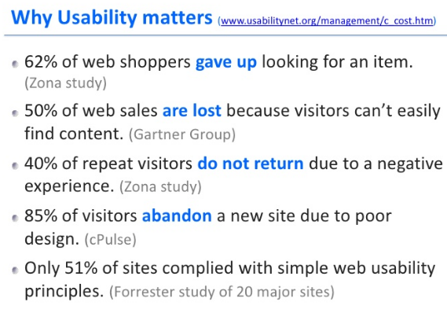

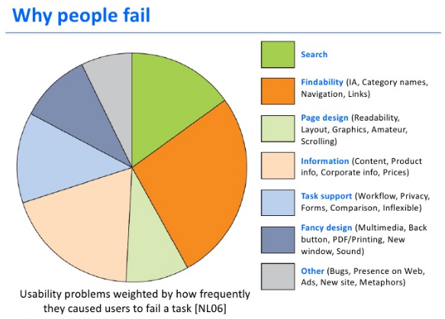

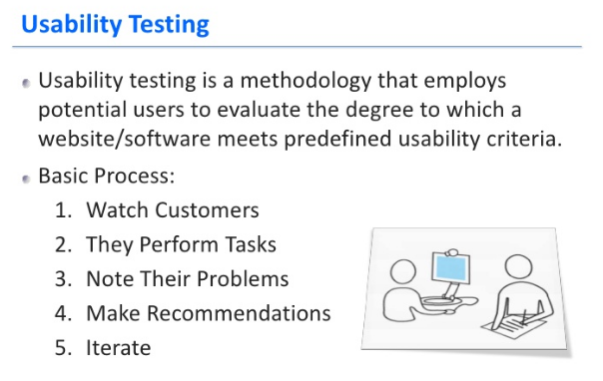

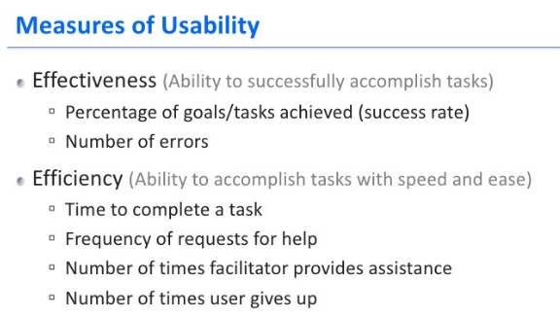  
  
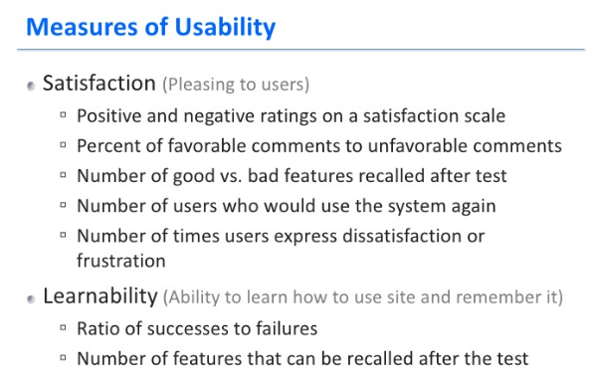

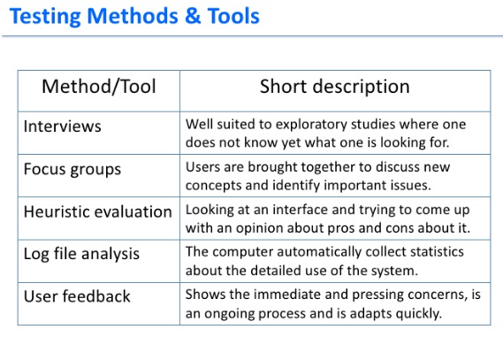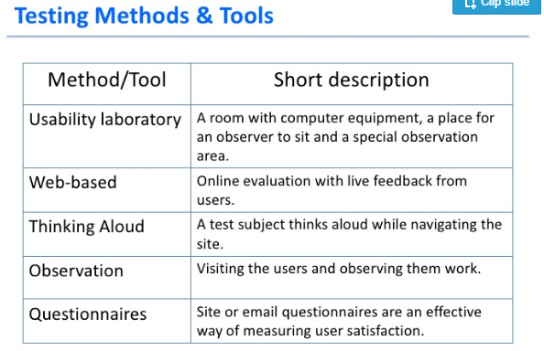

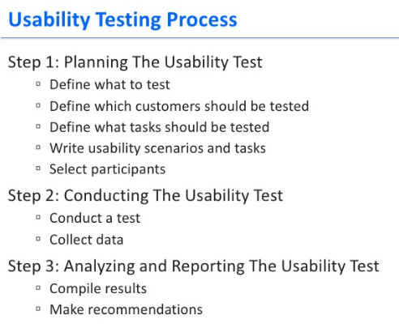

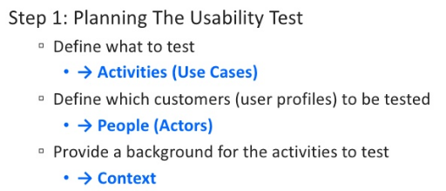

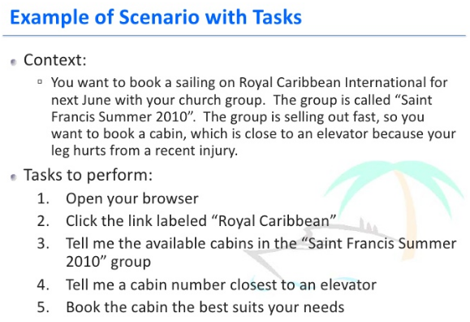

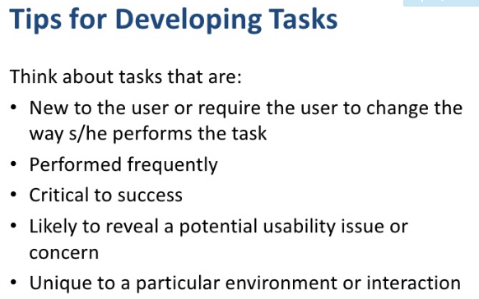

Examples of tests & recording results

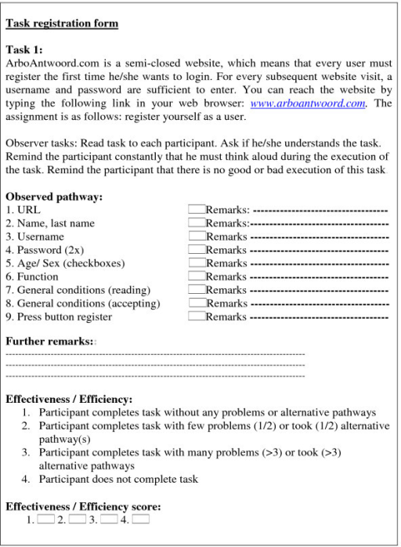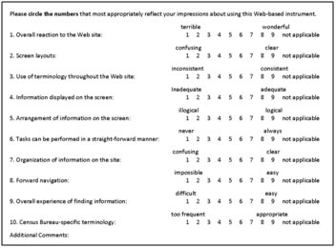

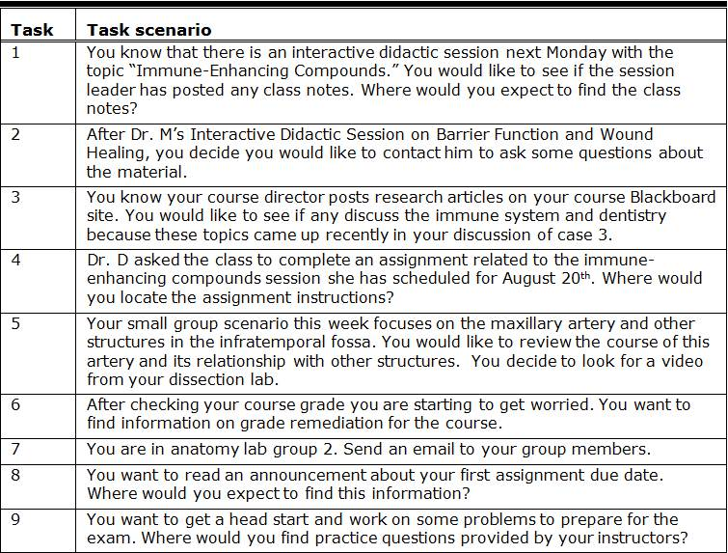

One example of a test plan template:

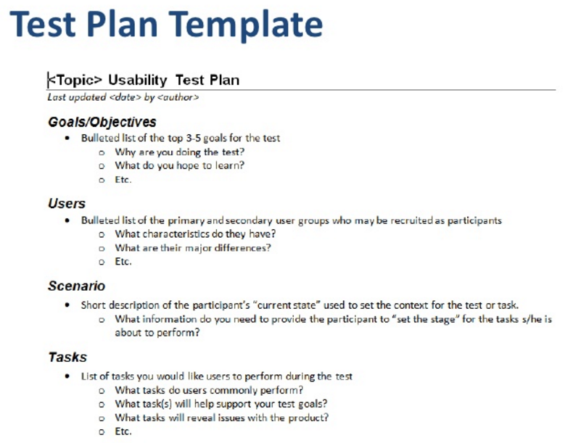

Example of a Usability test - plan

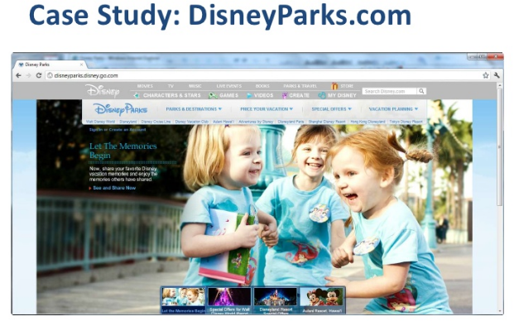

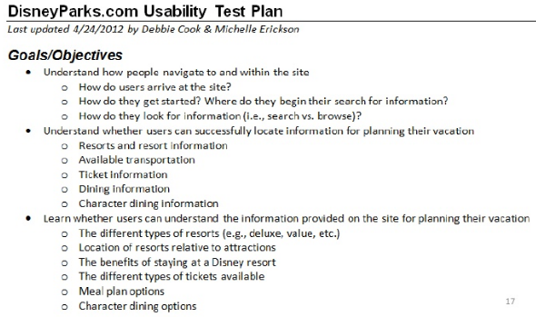 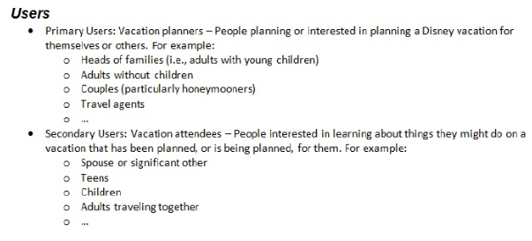

Example of a Usability test - tasks



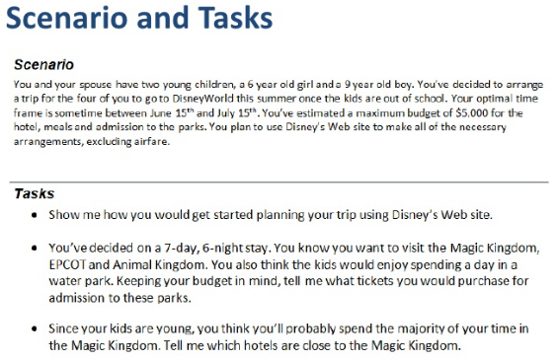

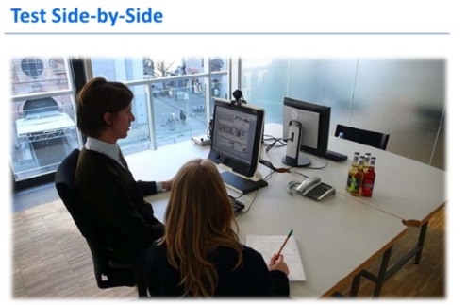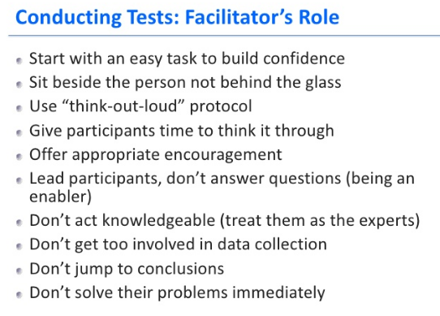

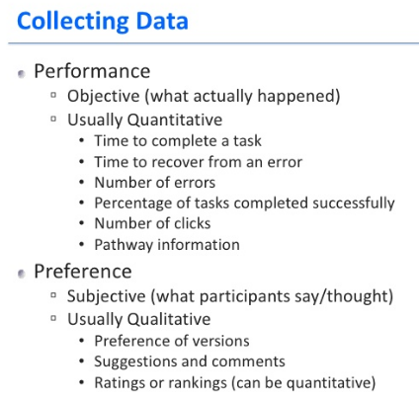

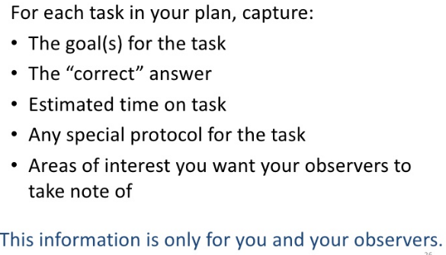

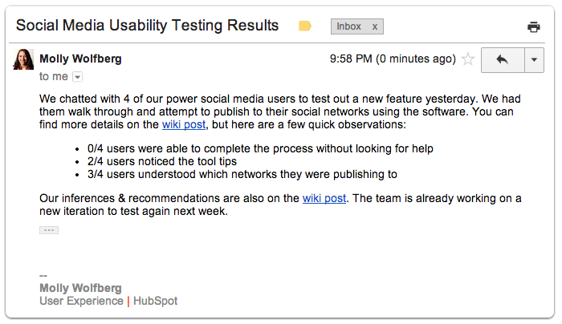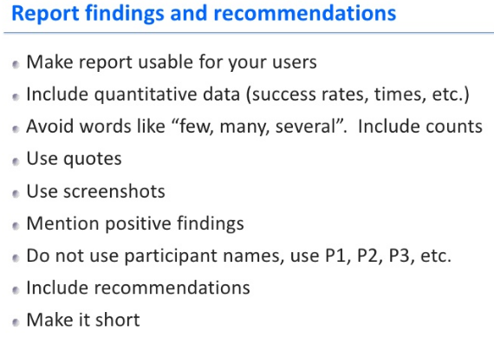

Before the test – Consent Form

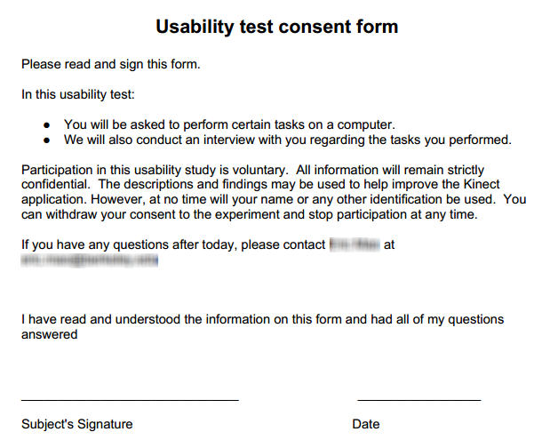

Usability Template:

Name of Project  
Usability Testing

Report writer’s name

Date

**Usability Template:**

**Overview**

Describe the users:

What criteria of eff & eff will you be testing?

Testing Method(s) / Tasks used:

**Testing Method 1:**

**Goal**:

**What** it is evaluating:

**Estimated time** that this task should take:

**Describe the method**: digital or in person, what tool is being used, time allowed, method of observation and recording of actions.

**Task**: Outline details here, either the questionnaire, the scenario or task that users need to complete

**Recorded results**

**Summary of Results**

Present the results in a table, graph, or text.

Testing method 1:

Testing method 2:

**Recommendations**

Changes to make to the solution:

|  |  |  |
| --- | --- | --- |
| **Change** | **Justification (reason)** | **Severity** |
|  |  |  |
|  |  |  |

**Appendix**

Add copies of questionnaire, task sheet, etc.

iRepairs  
Usability Testing

Tester: Ms Ho

26 July

**Usability Template: iRepairs example**

**OVERVIEW**

**Who**: five users, who are the staff and manager that operate iRepair’s storefront. The staff aged from 25 – 35 all male, competent computer skills. The manager, a lady in her 50s struggles with computers.

**Evaluation criteria that will test:**

* Efficiency : speed of completing a new device booking
* Effectiveness : ease of ability to fill in the form for a new device booking
* Effectiveness: sign up a new customer, add a booking for them
* Effectiveness : able to notice, and fix, any validation errors shown by form
* Efficiency: able to navigate through the ‘search customers’ feature
* Effectiveness: able to find the specific customer with ease
* Effectiveness: able to understand and use the sorting feature in jobs page
* Effectiveness: able to use the main menu, understand the labels used for buttons
* Confidence in navigation
* Satisfaction or frustration with product …. Etc.

**Testing Method(s) used:**

Method 1: Observation & thinking aloud  
 Method 2: Questionnaire

**TESTING METHOD 1: Observation & Thinking aloud**

**Goal**: to determine confidence, efficiency and effectiveness in making a new booking

**To evaluate these criteria:**

* Efficiency : speed of completing a new device booking
* Effectiveness : ease of ability to fill in the form for a new device booking
* Effectiveness : able to notice, and fix, any validation errors shown by form

**Estimated time** that this task should take: 2 minutes

**Describe the method**: in RL, observing their actions sitting next to them. (alternatively, film them)

**Task for users to complete:**

Scenario 1: An existing customer, Jamie, has broken her iphone6 screen. Book in a new job.   
Scenario 2: A new customer, Sam Shady, needs to book in a GalaxyS for volume button repair

**Results (repeat for each scenario):**

|  |  |  |  |
| --- | --- | --- | --- |
| **Scenario 1: new booking with existing customer** | **User A** | **User B** | **User C** |
| Able to find correct page | Yes | Yes |  |
| Able to enter data into form correctly | Approached it confidently | Unsure but used form correctly |  |
| Validation errors prompted? | Yes | Yes |  |
| Response to validation errors | Noticed them, but unable to fix the date field error | Yes and able to fix |  |
| Time taken: | 4 minutes | 2.8 minutes |  |
| Emotional responses | Frustration:  | | |  Satisfaction:  | | Frustration:  |  Satisfaction:  | | |  |
| Time taken: | 4.5 minutes | 2 minutes |  |

**TESTING METHOD 2: Questionnaire**

After the completion of each task, participants rated the ease or difficult of completing the task for five factors:

• It was easy for me to log in to the website

• It was easy for me to navigate through the menu to find the correct pages

• It was easy for me to place a new booking

• It was easy for me to add a new customer

• It was easy for me to locate a new customer, to add a booking for them

For example:

|  | **Strongly Disagree** | **Disagree** | **Neutral** | **Agree** | **Strongly Agree** | **Mean Rating** | **Percent Agree** |
| --- | --- | --- | --- | --- | --- | --- | --- |
| It was easy for me to log in to the website |  |  | 1 |  | 1 | 4 | 50% |

**Summary of RESULTS**

Five users completed both scenarios.

**Scenario 1:**

* 4/5 users were able to correct validation errors to successfully book a new job.
* 3/5 users said that the form was “pretty easy” to use and understand.
* Most frustration was caused by vague validation errors. In the follow-up questionnaire, UserA said “I don’t understand the format which the date field needs”.
* The average time taken to complete the task was 3 minutes.

**Scenario 2:**

* The time taken by users was quite long, averaging 4 minutes.
* Once entered, only 2 users were able to effectively locate that new user to make a new booking for them.
* User D suggested re-naming the menu item to “New Customer booking”

**RECOMMENDATIONS:**

**Changes/recommendations to make to the solution: *(perhaps display in table format as below)***

1. make validation errors more detailed, with examples of the required data formats
2. redesign the process (maybe combine the new customer & new booking onto one page) to speed up new bookings for NEW customers
3. consider clearer menu link names

| **Change** | **Justification** | **Severity** |
| --- | --- | --- |
| * make validation errors more detailed, with examples of the required data formats | Some participants found it difficult to understand the format of data required | High |